**The American Parliamentary Style of Debating (APDA) Rules**

* The American Parliamentary Debate rules apply in all rounds. According to the American Parliamentary Debate, two teams of two persons each engage one another through a series of seven-minute speeches. The two sides in the debate are the Government and the Opposition, each represented by one team.
* Debating is a clash of arguments b/w the Government (Affirmative/Proposition team & the Opposition (Negative) team. The 1st affirms the motion, whereas the 2nd opposes it.
* Motion is a topic each team should contextualize.
* The objective of debating is to argue on policies or propositions of thought; urgent or not, good or bad, effective or not effective, useful or useless, etc.
* The AUE Debate and Public Speaking tournament will aim to find the best team and speakers in the English and Arabic tracks.
* The Teams:

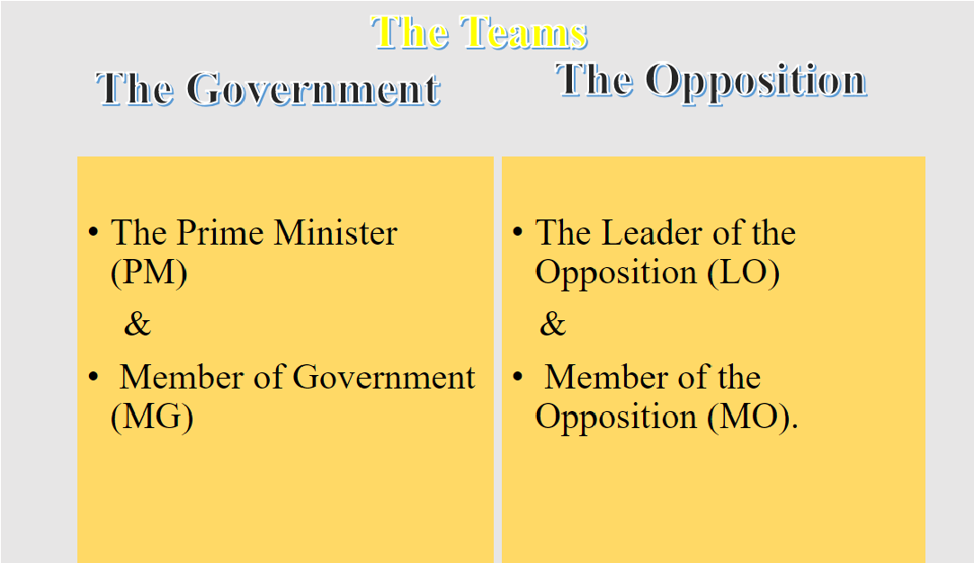

* Speakers’ Order:

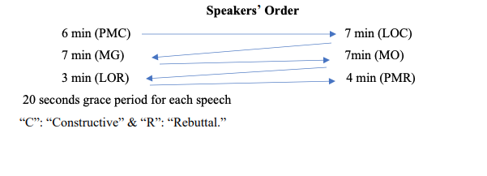

* The Speeches:

|  |  |
| --- | --- |
| 1.Prime Minister’s Constructive (7 minutes & a 20-second grace period)   1. State a clear case statement that does not violate any debate rules. 2. Offer any further explanation or background for the case. 3. Present a case consisting of arguments that support the case statement. | 1.Leader of Opposition’s Constructive (8 min. & a 20-sec. grace period)   1. State any important objections to the case. 2. Construct the Opposition’s (3) independent arguments. 3. Attack the government’s case. |
| 2.Member of Government’s Constructive  (8 min. & a 20sec. grace period)   1. Introduce any remaining Government material. 2. Respond to the LO’s attacks. 3. Reconstruct the Government’s case. | 2.Member of Opposition’s Constructive (8 min. & a 20-sec. grace period)   1. Introduce any new Opposition arguments. 2. Respond to the MG. 3. Respond to any Gov. arguments that have not been responded to. |

* Rebuttals:

|  |
| --- |
| 1.Leader of Opposition’s Rebuttal (4 min. & a 20 sec. grace period)   1. Crystallize the round into clear Opposition voting issues. 2. Preempt any problems due to lack of clarity or objections the Opposition has made to the case. 3. No new arguments may be made, but new examples are welcome. |
| 2.Prime Minister’s Rebuttal (5 min. & a 20 sec. grace period)   1. Respond to any new MO arguments. 2. Crystallize the round into clear Government voting issues. 3. No new arguments may be made, but new examples are welcome. |
| **Total: 40 min. +2 min. grace period** |

* New Arguments: New arguments can be made at any time during the first four speeches, but they cannot be made during rebuttals, the last two speeches of the round. The Prime Minister can, however, respond to new opposition arguments that were made during the

MO, so the PMR may contain new responses but not new arguments.

* Parliament: the audience (the House)
* Timekeeper: monitors the time limits throughout the debate round& does the appropriate time signals.
* Judge panel: impartial, impersonal
* The speaker: head of the judging panel, arbiter of the rules, invites debaters for their speeches, decides upon points of order & personal privilege.
* Motions:

1. Semi-closed motions - also broad in scope. This House would pay compensation to victims of abuse.
2. Closed motions - specific in scope while still leaving room for interpretation. This House would make Germany compensate victims of Nazi atrocities.
3. Value-judgment motions - defending a specific value, good or bad: This House believes that the Internet is dangerous.
4. Policy debates - introducing a specific plan of action into Social Quotient (SQ) TH supports the concept of a “Green Economy”.
5. Motions can be time-space (set in a specific time or space under those conditions) and/or involve actor analysis (analyzing what a specific person or entity should do). Popular topics are international relations, economics, philosophy, science, social justice, media, and art.

* Points of Information (POI):
  1. A POI is a question or statement directed to the speaker holding the floor by an opposing team member.
  2. To offer a POI, the debater should rise & indicate that he/she wishes to offer a point by saying "Point of information" or "Information" or “On that very point."
  3. The speaker has absolute discretion over whether or not to accept a POI; this should be indicated within 10 or 15 seconds after the other debater rose.
  4. If the POI is refused, the individual should sit down. If the POI is accepted, it must be no more than 15 seconds & will count against the time of the speaker holding the

floor.

* 1. POIs may be offered b/w the 1st & last minutes of the 4 constructive speeches but are prohibited during rebuttals.
  2. POIs can help a debater’s speaker points, & debaters are encouraged to accept & ask

POIs.

* 1. Recommended: each speaker accepts 2 or 3 POIs.
* Points of Personal Privilege: In case of being seriously misquoted, misrepresented, or insulted by a member of the opposing team a debater may rise on a point of personal privilege.
* Points of Order: A point of order is an objection to a breach of the rules of debate that is raised by a debater while one of the members of the other team is speaking. To offer a point of order, a debater should rise & state "Point of order." The speaker holding the floor should stop speaking and remain silent until the point is stated, & the Speaker has ruled it well taken or not well taken. If a point is ruled well taken, the time involved in raising the point will be deducted from the speaker's time. If the point is ruled not well taken, no time will be deducted from the speaker.